Table of Contents
Additional Resources 1
CUPE3092 Resources 1
Greenshield Resources 1
Section 1: Your Benefits 2
1.1 Base and Top-up Plans 2
1.2 What is Covered? 3
1.3: Table of Maximums 3
Section 2: Using Greenshield 4
2.1 Making an Account 5
2.2 Checking Coverage 10
2.3 Submitting a Claim 14
2.4 Checking Existing Claims 20
Section 3: Community Notes 22
Public Speaking Training for Academics 23
Free Massages 23
Eyewear and Eye Exam Deals 23
Where to find Doctors? 23

Additional Resources
This document serves as a student-focused summary of the information you need to use your medical benefits. If needed, further information, including information on dependents, can be found from both our union (CUPE3902) and our insurance provider (Greenshield). CUPE3902 can help best with questions about university systems, policies, and procedures, while Greenshield can help best with questions about their website, your coverage, and your claims.

CUPE3092 Resources
Key information about your benefits package can be found in CUPE3902’s FAQ page
Broader information about your benefits can be found at CUPE3902’s Benefits Page
Your primary CUPE3902 / university contact is Ellen DeLeon: benefits@cupe3902.org

Greenshield Resources
Instructions, including video tutorials, for using the Greenshield website, as well as information about benefits, can be found in the GreenShield+ Help Centre.
Greenshield customer support can be reached at: 1-888-711-1119 Mon to Fri 8:30 a.m. – 8:30 p.m. Greenshield customer support will not only answer questions but can also edit existing claims over the phone.
Greenshield email inquiries can be made with the Greenshield Contact Form

Section 1: Your Benefits

1.1 Base and Top-up Plans
The GSU Base Plan is available to all students. The CUPE 3902 Unit 1Top-up Plan is available to all student employees (teaching assistants, laboratory assistants, invigilators, etc.). Since all PhD students are entitled to a teaching assistantship, all students can access the Top-up Plan. Once you have been issued an official paycheck for at least 15 hours of work at UofT between September 2024 and August 2025, you will automatically be granted the Top-up Plan.
Access to the Top-up Plan is retroactive. Once you have finished working 15 hours, you receive coverage for expenses backdated to the start of September. For example, imagine you incurred a medical expense in October 2025, but do not start your TA position until April 2026. You can still claim and be reimbursed for that October medical expense through the Top-up Plan once it becomes active in April. If you submitted a claim for that expense in October through the GSU Base Plan, you may still resubmit it in April to receive the additional reimbursement covered by the Top-up Plan.
More details can be found on the CUPE 3092 website.

1.2 What is Covered?
The services and amounts covered by your health insurance are found in the Table of Maximums.
If you have the Top-up Plan, then the total coverage amounts are the amount in the GSU Base plan PLUS the amount in the Top-up plan. For instance, for massage therapy, the GSU Base Plan covers $25 per visit up to a maximum of $500 and the Top-Up plan covers $35 a visit up to $700. This means that, with the Top-up Plan, you are covered for $60 per visit up to $1200 per year.
The table of maximums does not explain Greenshield’s limits such as maximum drug prices and maximum costs per service hour. These can only be found on Greenshield (see Section 2.2).
You also have access to a Healthcare Spending Account (HCSA): $300 from the Top-up Plan (with an additional $300 if you have a dependent). Your HCSA covers non-standard paramedical expenses (e.g., personal training) and can also be used to cover out-of-pocket portions of regular expenses (i.e., if you were charged $170 for a service and only $150 was covered, you can charge $20 to your HCSA).

1.3: Table of Maximums
Annual (September 2024 – August 2025) Health Benefits Coverage
 |  | GSU Base Plan | CUPE 3902 Unit 1  Top-up Plan
General | Most prescription drugs | 80% to $5,000 | 90% to $15,000
General | Clinical Psychologist / MSW Counsellor / Psychotherapy | 100% to $750 | 100% to $5,000
General | Speech Therapist | 100% to $1,000 | 100% to $1,300
General | Orthotics | $350 | $100 (limit 1 pair/year)
General | Travel Insurance | See GSU info for details | No additional coverage
Paramedical | Registered Massage Therapy | $25/visit to $500 | $35/visit to $700
Paramedical | Chiropractic | $15/visit to $300 | $45/visit to $900
Paramedical | Physiotherapy | $30/visit to $600 | $50/visit to $1000
Paramedical | Naturopathic Doctor | $15/visit to $300 | $45/visit to $600
Paramedical | Acupuncturist | $15/visit to $300 | $45/visit to $600
Paramedical | Combined Paramedical Cap | $2,000 | $1,300
Dental | Preventative | 70% | 80%
Dental | Basic | 70% | 80%
Dental | Major restorative | $0 | 50%
Dental | Combined Dental Cap | $550 | $1,350
Vision | Exam | $75 per 24 months | $15 per 24 months
Vision | Eyewear | $125 per 24 months | $300 per 24 months
Vision | Health Plan Overall Cap  (includes all above as well as other covered services and medical equipment) | $10,000 | $15,000  (in addition to $15,000 prescription cap)

Section 2: Using Greenshield

2.1 Making an Account
To submit claims, you need an account on Greenshield, our third-party insurance provider’s website: https://www.greenshield.ca/en-ca
Please note that you will need a separate account for the Top-up Plan. That means you will need to make TWO Greenshield accounts, one for the GSU Base Plan and one for the Top-Up Plan. You can follow these steps twice, once for each account. Your GSU Base Plan account will be your primary.
For a video tutorial on making an account, click here. (FIRST VIDEO) If you use the video, you may still need to check the steps below for UofT-specific information.
Your Greenshield Member ID for the GSU Base Plan will be “UTG” + your student number + “00” For example, if your student number is 1009266, your Green Shield ID number for the Top Up Plan is UTA1009266-00.
Your Greenshield Member ID for the Top-Up Plan will be "UTA" + your personnel number + "-00" To find your personnel number please refer to the HR Service Centre. For example, if your personnel number is 1001234, your Green Shield ID number for the Top Up Plan is UTA1001234-00.

2.1 Step 1: On greenshield.ca, click “Sign In” à “GreenShield+ member sign in”
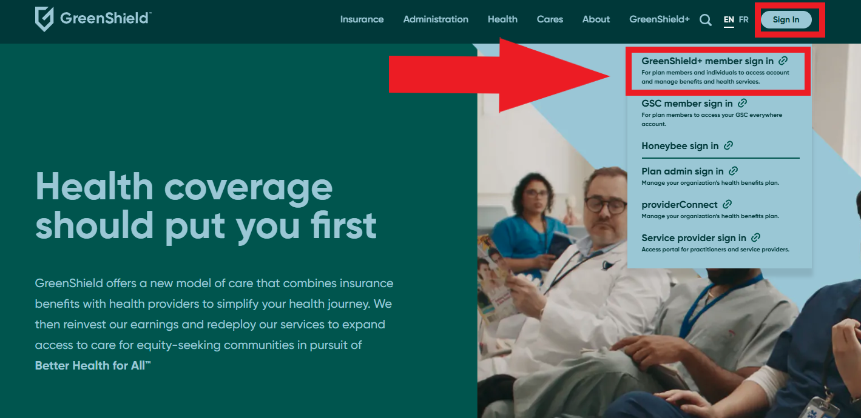

2.1 Step 3: On the following page, click “Sign Up”
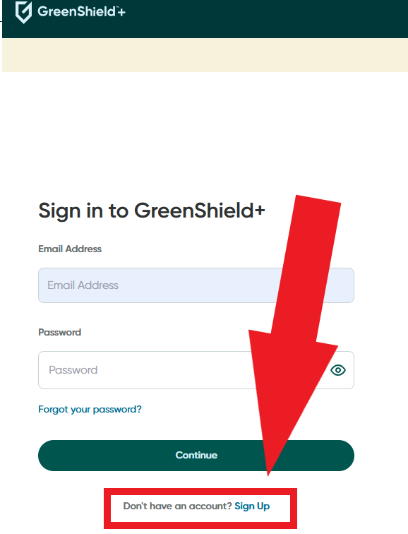

2.1 Step 4: Select “Through an employer or organization” à “Continue”
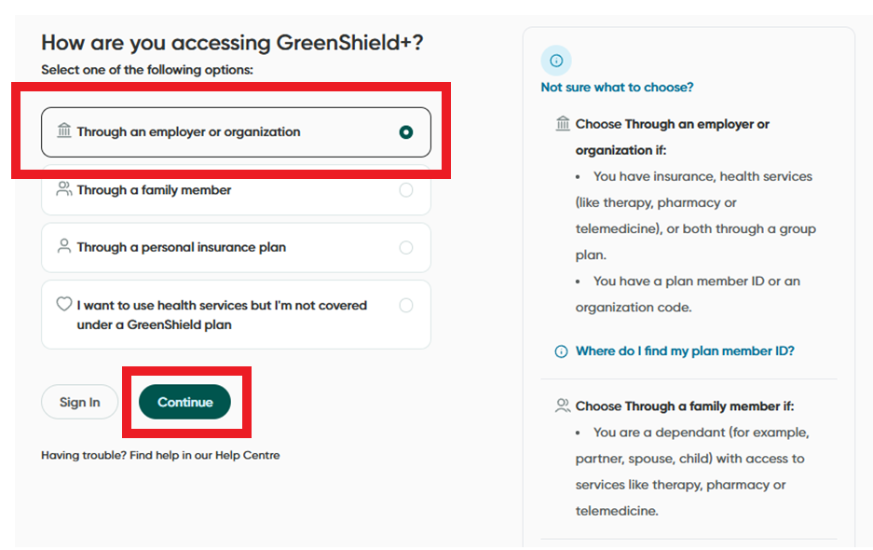

2.1 Step 4: Select “I have a member ID” à “Continue”
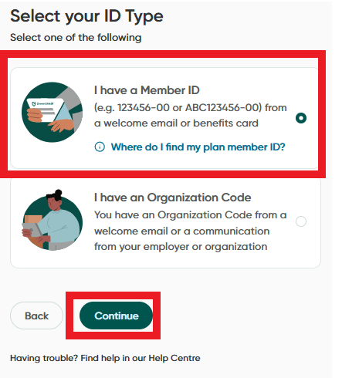

2.1 Step 5: Enter your email address.
NOTE: This does NOT need to be your UofT email address, any email address works.
NOTE: You must use two different emails for your GSU Base Plan and Top-up Plan accounts. Use an email you check more often for your GSU Base Plan.
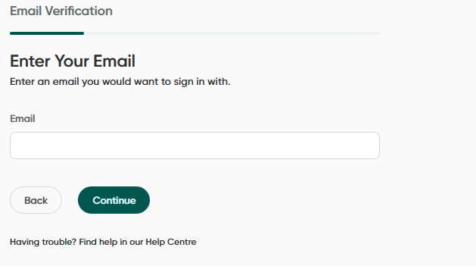

2.1 Step 4: A verification code will be sent to your email. Enter it in the box, then click “Verify Code”
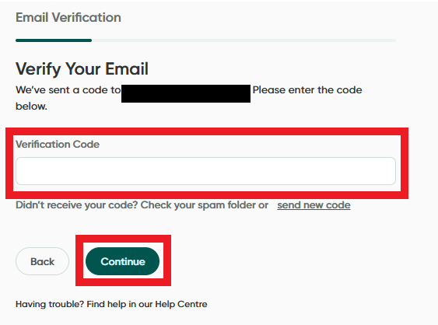

2.1 Step 5: Enter your Member ID. When completing this step for your GSU Base Plan Account, use “UTG” + your student number + “00”. When repeating this step for your Top-up Plan account, use "UTA" + your personnel number + "-00"
Then, fill in your date of birth, number of active dependents (if any), and click “Next”
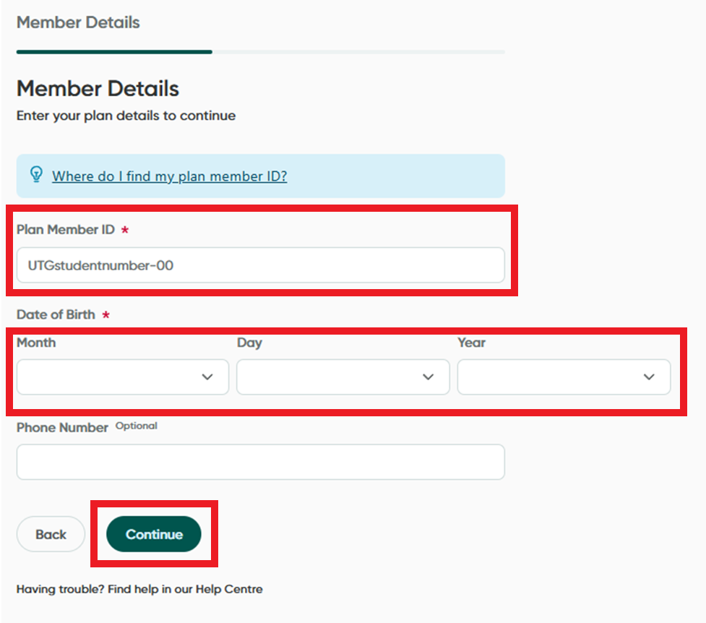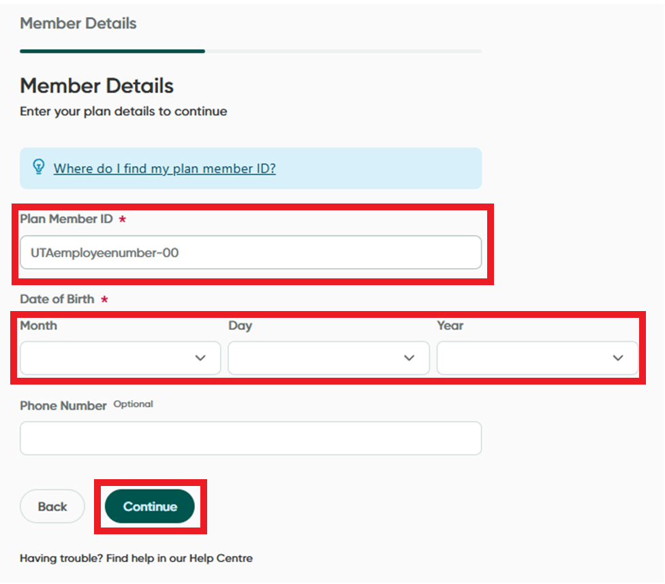

2.1 Step 5: Following the remaining steps to create a password. You may also be asked to enter personal and direct deposit information on the following pages.

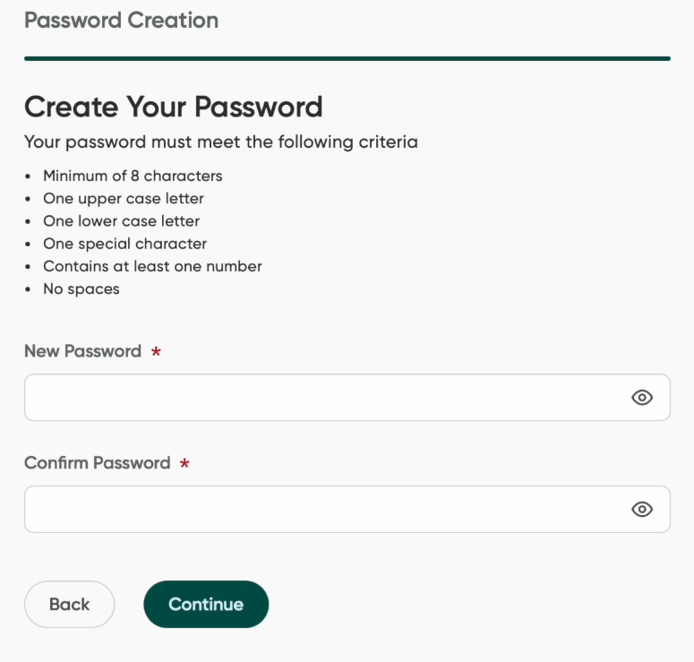

2.1 Login: You may now log into Greenshield greenshield.ca, click “Sign In” à “GreenShield+ member sign in”

2.2 Checking Coverage
If possible, you should always check your coverage before incurring a medical expense. Most products and services have limits that are set by Greenshield and are not explained in the Table of Maximums. Every product, including all drugs, have a maximum price. If you are sold a product at a price higher than the maximum, you must pay the difference out of pocket or your HCSA. Most services also have limits. For instance, if counselling sessions are limited at $150 per 60 minutes, and you are charged over $150 or only billed for 50 minutes, you will pay the difference out of pocket or HCSA.
Click this link for a video tutorial on how to check your coverage. If you use the video, you may still need to check the steps below for UofT-specific information.
Following these steps will only show you the coverage for the plan you are logged into. To find your full coverage, complete these steps in BOTH your student AND employee Greenshield accounts, and add the amounts together to find your full coverage. Sometimes, the coverage checker on your Top-up Plan Account fails and shows “$0”. You may also call Greenshield support at 1-888-711-1119 to check coverage amounts or refer to the Benefit Booklet.
2.2 Step 1: On your dashboard, click “Claims and Benefits” à “Check Coverage”
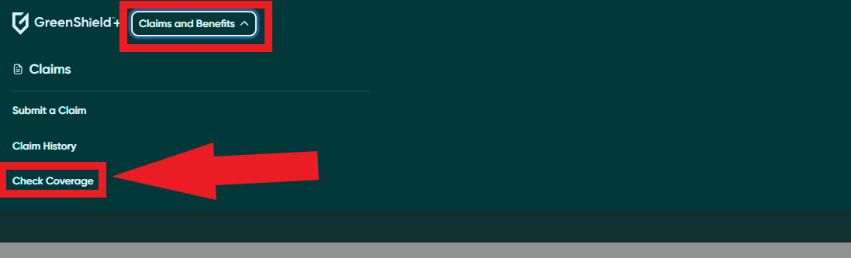

2.2 Step 2: Select a product or service. Either type its name into the search bar and select it in the drop-down menu or select it from the list below
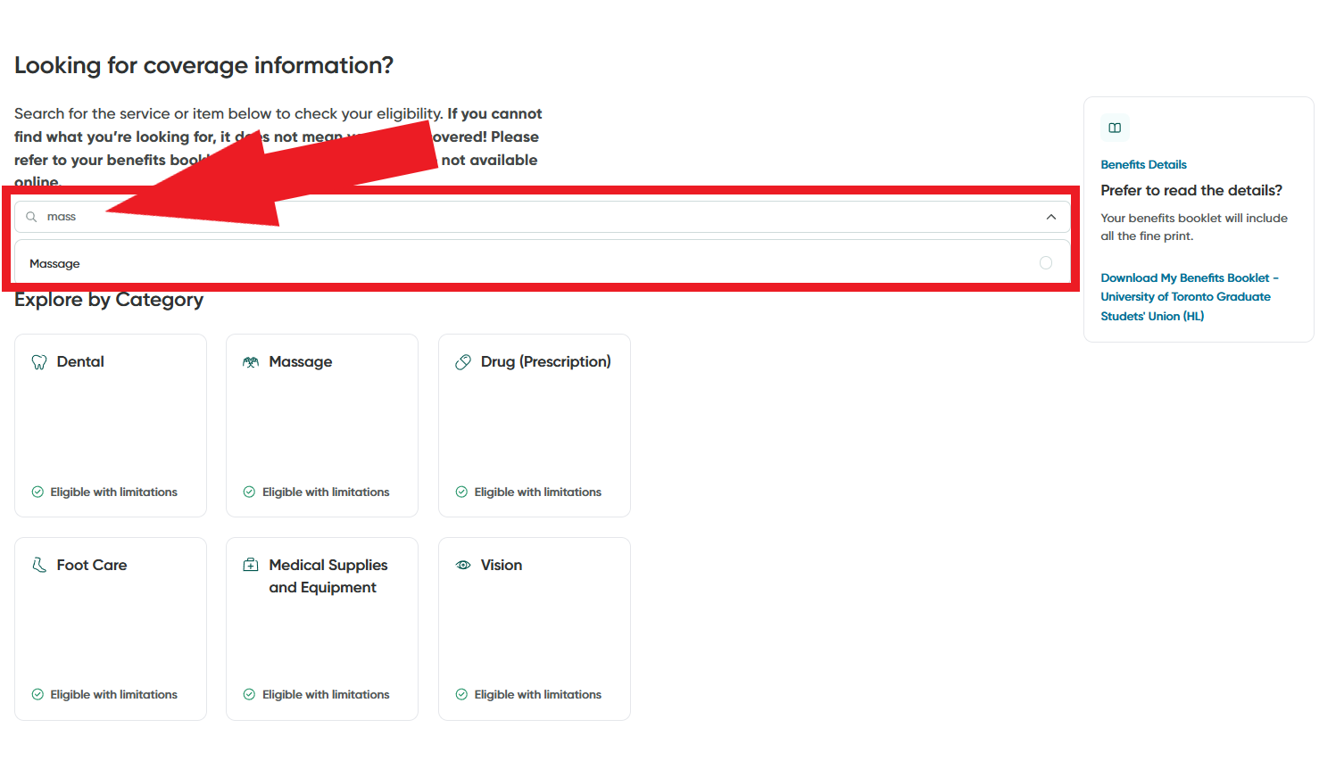

NOTE: This page contains your Benefits Booklet, the detailed terms of your plan. The corresponding Benefits Booklet will be available depending on whether you are logged into your GSU Base Plan or Top-up Plan account.
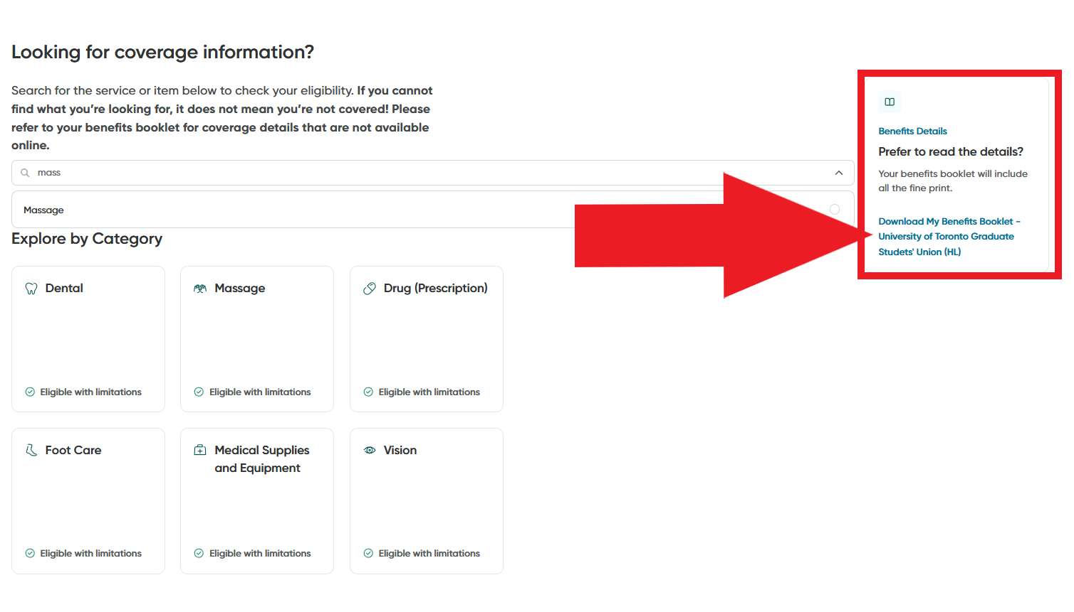
2.2 Step 3: Enter the amount you expect to spend, the duration (if you are entering a service), and click “Continue to Estimate”

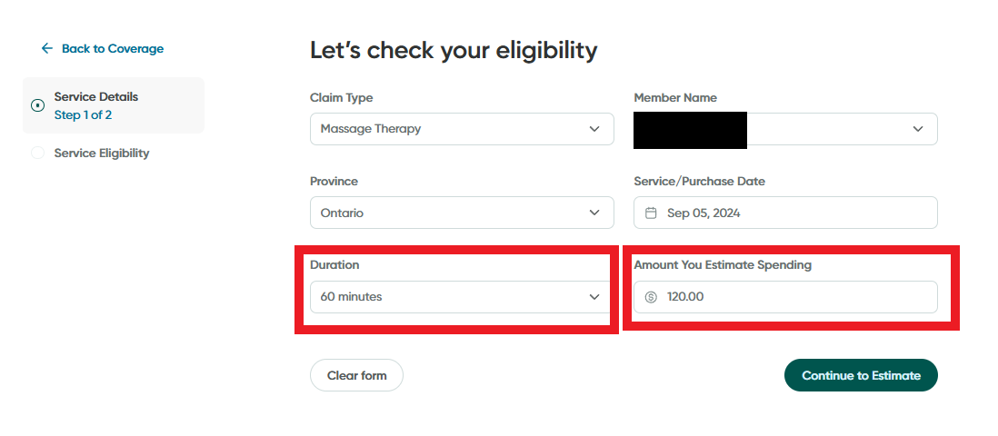

2.2 Step 3: You will be shown your eligible coverage amount, the ineligible amount (paid by either your other plan, your HCSA, or out of pocket), and the amount you have spent to date / have remaining.
NOTE: (These numbers are ONLY for the plan you are logged into)
NOTE: If these numbers ever conflict with the Table of Maximums, double-check them either through your Benefits Booklet or calling Greenshield support at 1-888-711-1119
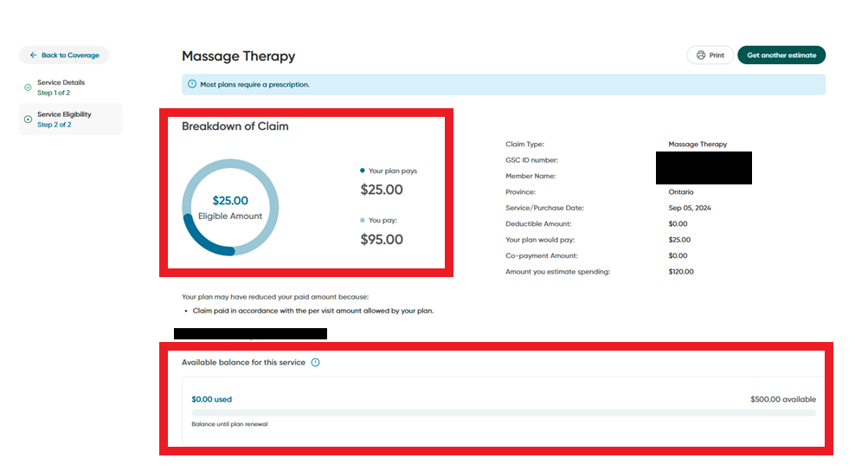

2.3 Submitting a Claim
NOTE: Many providers do have direct billing. If you request direct billing, make sure that they send the claim through BOTH your GSU Base Plan and Top-up Plan accounts. Otherwise, you will still need to make a manual claim later.
To make a claim, log into your GSU Base Plan account. You should only make claims through your GSU Base Plan account.
Click this link for a video tutorial on how to submit a claim. If you use the video, you may still need to check the steps below for UofT-specific information.
2.3 Step 1: Click the “Submit a Claim” button on your dashboard.


2.3 Step 2a: Search for and select the correct claim type
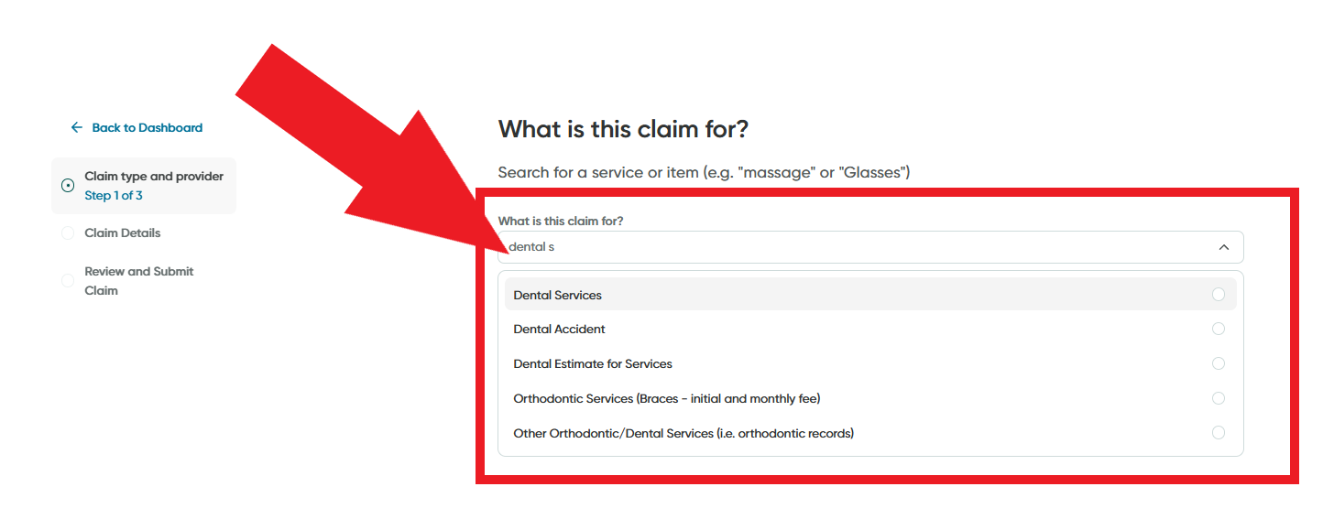

2.3 Step 2b: If this service is tied to a specific office or practitioner, either select the provider from the “Recent Providers” list, or click “Search Provider” and enter their last name OR phone number.
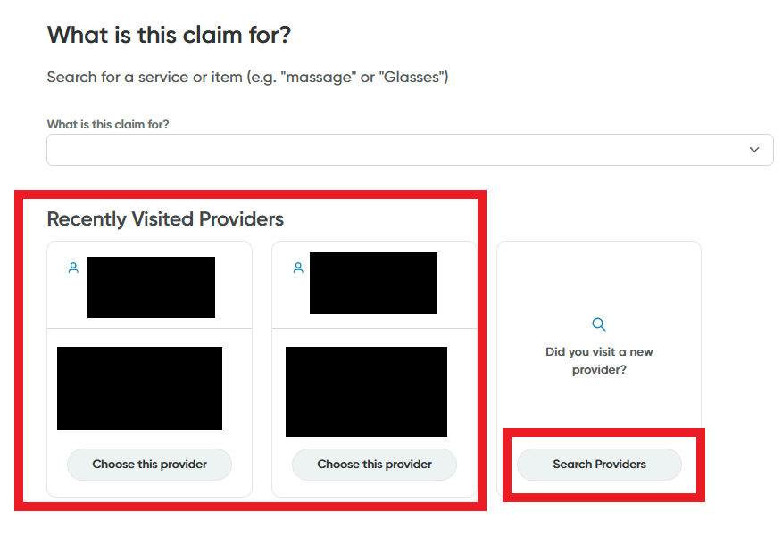
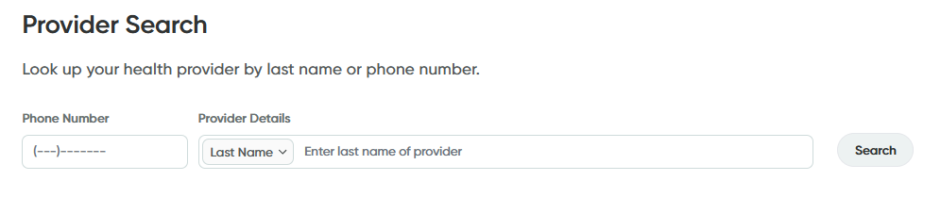

If you cannot find your provider with the search function, you will be given the option to either “Skip Provider Search” and upload necessary documents later or “Add as new provider” manually, depending on claim type.
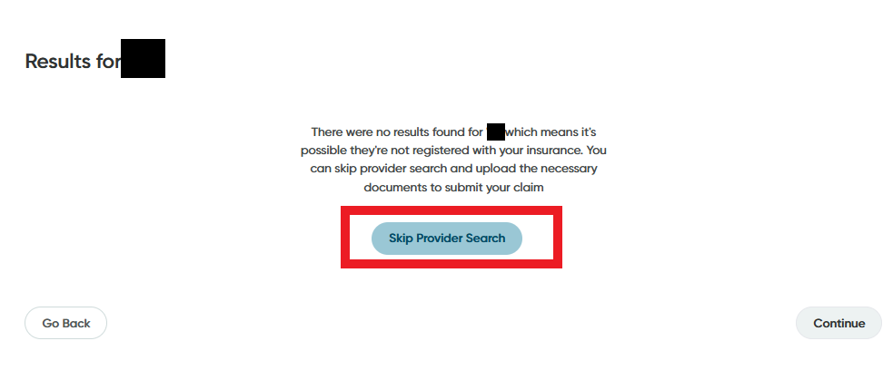

2.3 Step 3a: Select the person the claim is for (i.e., you or a dependent).
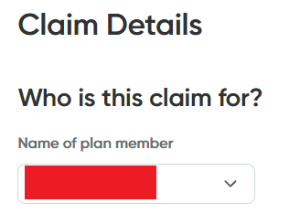

2.3 Step 3b: If your Top-up Plan is active, follow this step to submit to BOTH plans simultaneously. If your Top-up Plan is inactive, skip to Step 3c.
For “Is YourName covered under another benefits plan, select “Yes”.
For “Is the plan with GSC?” select “Yes”
For “Has this claim already been submitted to the other plan? Select “No”
For “Would you like to submit any unpaid amount to the other plan” Select “Yes”
In “Other GSC ID number” enter your Top-up Plan ID WITHOUT the “-00” - “UTAemployeenumber”
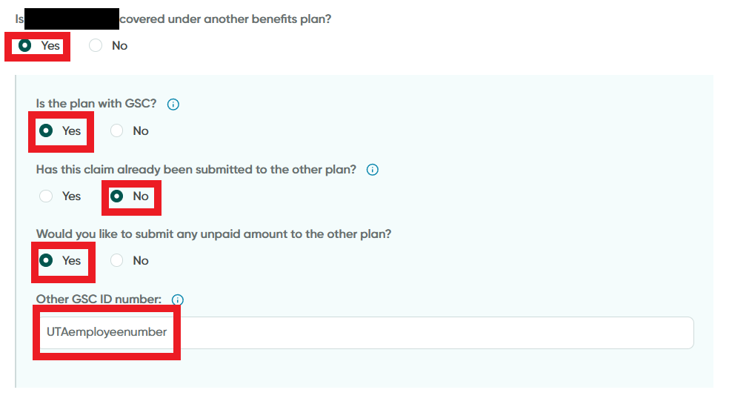

2.3 Step 3c: If your Top-up plan is inactive, follow this step.
NOTE: When your Top-up Plan becomes active after working 15 hours, you will need to resubmit the claim following Step 3b to receive the rest of the coverage. Or you may call Greenshield at 1-888-711-1119 and they will do it for you.
For Is YourName covered under another benefits plan? Select “No”
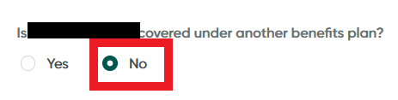
2.3 Step 4: Fill in any requested additional information about your claim. This will differ depending on the nature of your claim (examples below). Some will ask for prices, procedure lengths, or service codes. Others will ask for documentation (e.g., receipts, prescriptions, etc.).
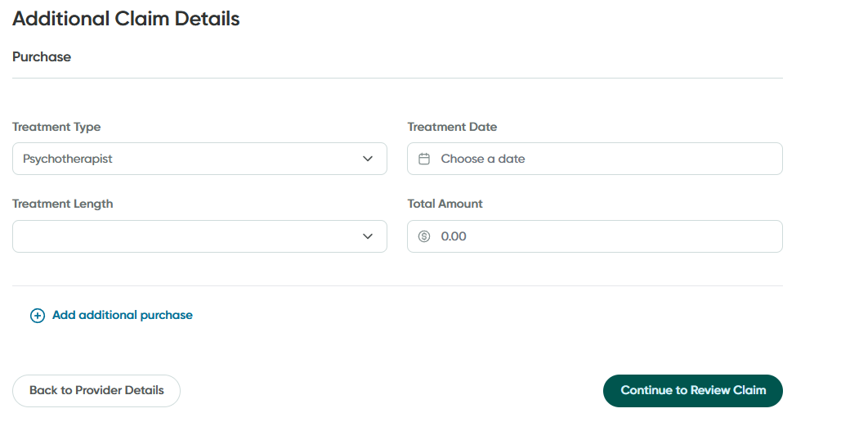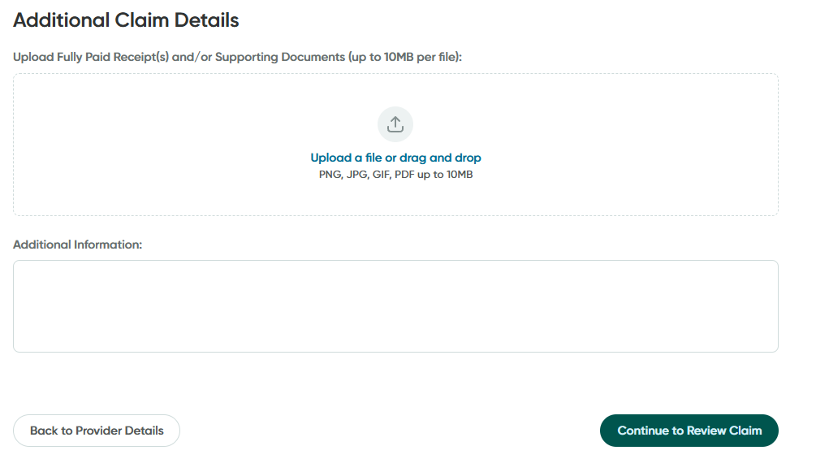

2.3 Step 5: You will be asked to review your claim before submitting. Make any necessary Edits with the Edit buttons, check the box next to “I confirm” and “Submit Claim” to submit the claim.
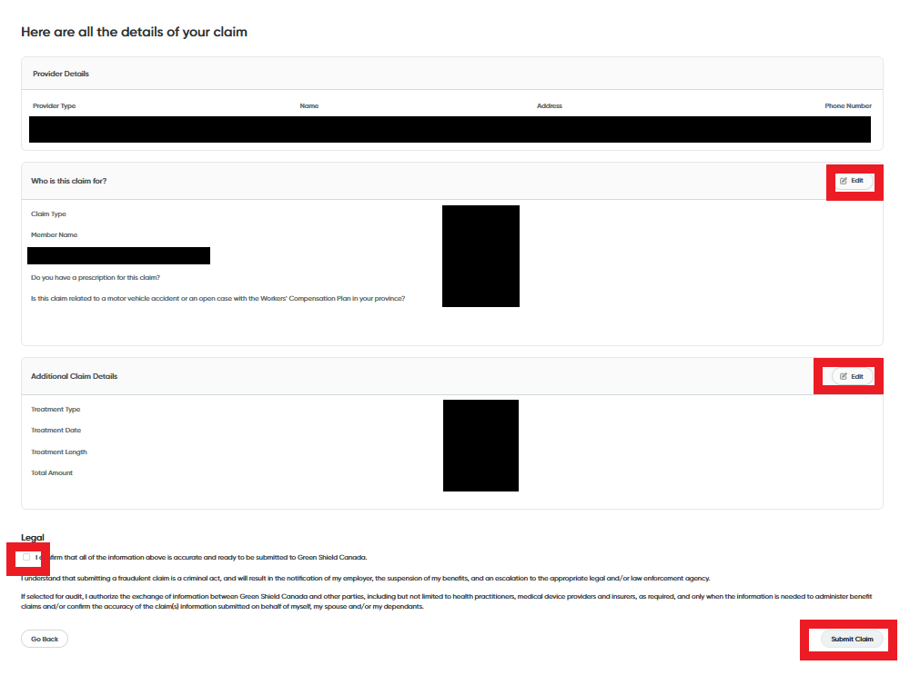
NOTE: Most claims are then submitted instantly and will be paid out within a few business days. However, some claims are randomly selected for audits, which will require you to upload further documentation, usually receipts. Other claims may need to be confirmed with the practitioner and have longer processing times.
NOTE: If you have used all the coverage on your GSU Base Plan, and the service is being paid by your Top-up Plan, the claim will show as “Denied” despite being processed normally in your Top-up Plan. To see the status of such claims, log into your Top-up Plan.

2.4 Checking Existing Claims
Click here for a video tutorial on checking your claims. Or follow the steps below.
All your existing claims can be found in “Claims and Benefits” à “Claim History”
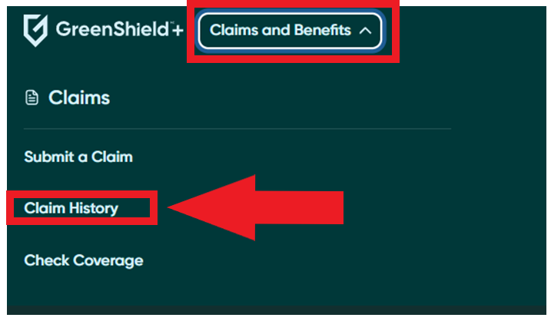
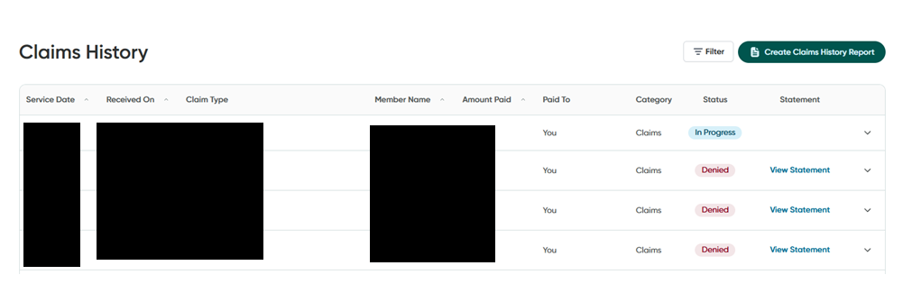

Click “Filter” to filter your past claims by Type, Date, Beneficiary, Status, and Category.

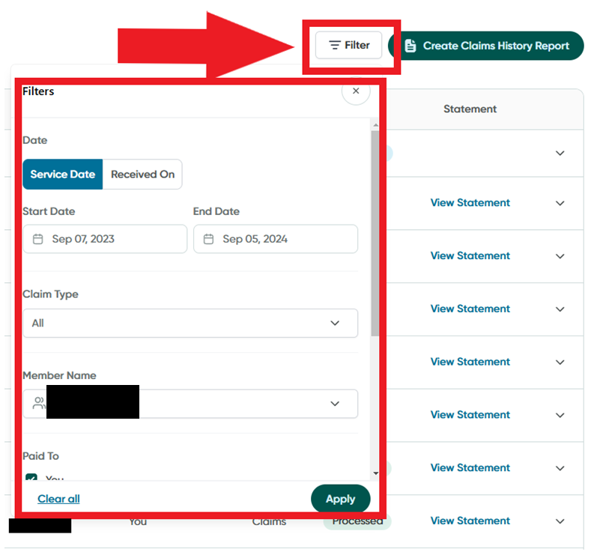

Section 3: Community Notes

This section contains student suggestions about how to use your benefits. If you have any helpful, creative, or interesting tips about how or where to use your benefits, please email them to andrew.perossa@mail.utoronto.ca.

Speech Training for Academics
- Speech therapy coverage does not only include speech disorder treatment. You are also covered for public speaking training, voice coaching, accent and dialect coaching, professional communication, and more. Many speech therapists, online and in person, will tailor their services to academic needs such as conference presentation skills.
  - One example: Well Said: Toronto Speech Therapy

Free Massages
- Bay and College Physiotherapy and Rehab (790 Bay St. Unit no. 105) offers discounted massages for students: $35 for 15 minutes and $50 for 30 minutes). This means that 15-minute massage are free for all students and 30-minute massages are free with the top up plan.

Eyewear and Eye Exam Deals
- Costco has good deals on glasses, and can be entered with a gift card instead of a membership
- Clearly has good deals on glasses plus a UofT discount.
  - Most Canadian optometrists will not provide you with your pupillary distance when buying glasses or having an eye exam to prevent you from buying cheap glasses online. However, the Clearly store (315 Queen St West) will provide them with eye exams, if requested up front.

Where to find Doctors?
- UofT list of doctors on/near campus

